EN 2040

Random Signals and Processes

Simulation Assignment

Report

H.K.R.L. GunaSEKARA

180205H

Q3)

Q4)

Q5)

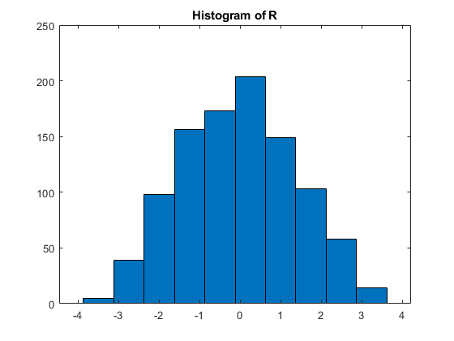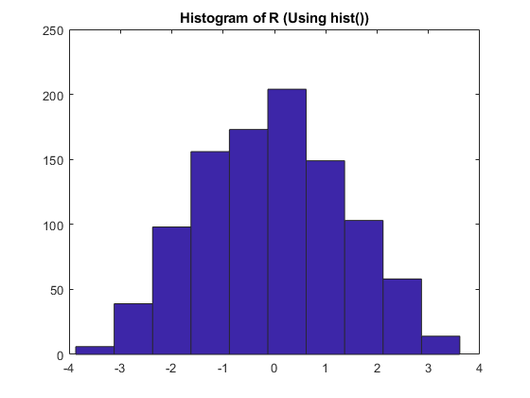

The histograms have a distant appearance of Gaussian distribution.

a)

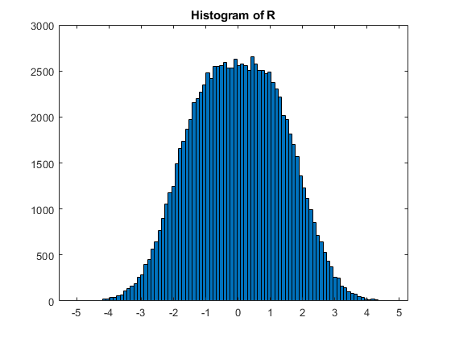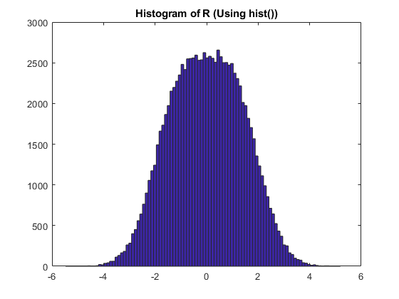

Upon increasing the no of bins, histograms have obtained a close look of Gaussian distribution.

b)

When A increases the pdfs deviates from its initial positions when A=1.

This is due to mean values of the pdfs is -A for and A for

c)

For the expected value,

Where,

|  |  |  |  |
| --- | --- | --- | --- |
| A | E [R|S = A] | E [R|S = -A] | E [R] |
| 1 | 1.0025 | -1.0017 | 0.003864 |
| 2 | 1.9976 | -2.0006 | -0.0012 |
| 3 | 3.0006 | -3.0068 | -0.0029 |

d)

Q6)

b)

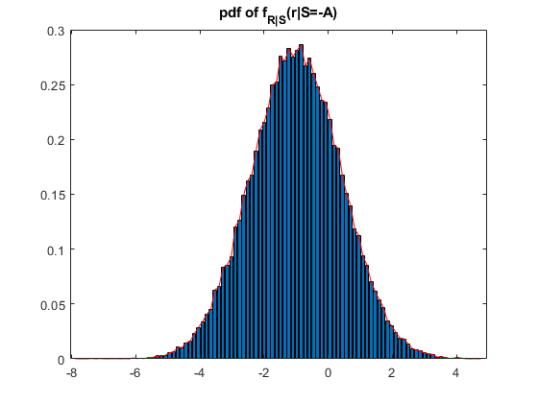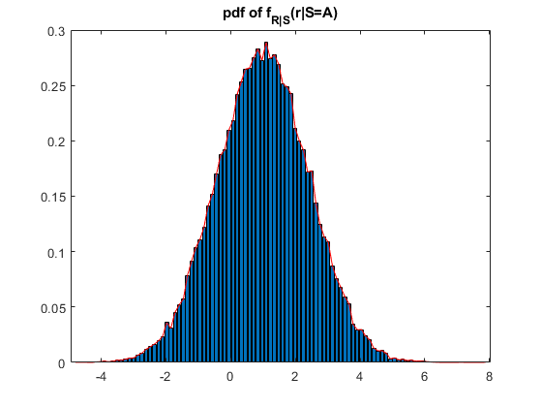

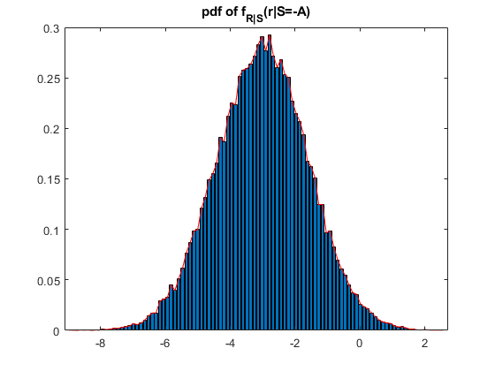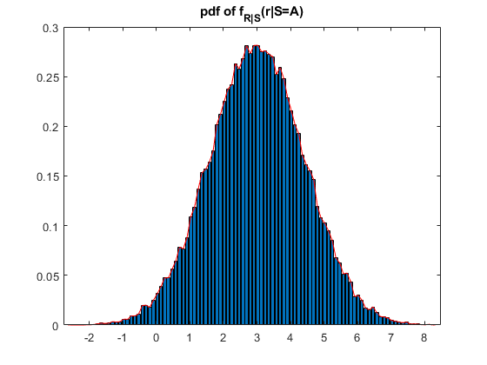

c)

|  |  |  |  |
| --- | --- | --- | --- |
| A | E [R|S = A] | E [R|S = -A] | E [R] |
| 1 | 0.9965 | -0.9965 | -0.000091 |
| 2 | 2.0001 | -2.0088 | -0.0044 |
| 3 | 2.999 | -3.0159 | -0.0081 |

d)

When increasing A, the middle separation of increases, but it is not quite dominant as without the interference (in Q5-d). This is due to interference another Gaussian random signal gets added to the Initial Signal which increased the variance of both and .

Q7)

b)

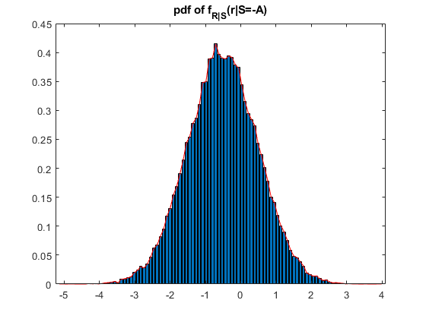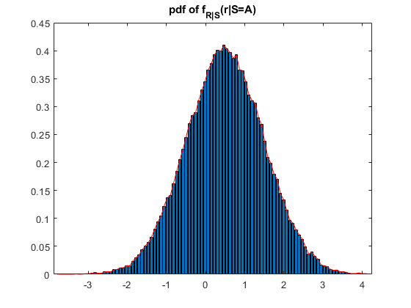

c)

|  |  |  |  |
| --- | --- | --- | --- |
| α | E [R|S = A] | E [R|S = -A] | E [R] |
| 0.5 | 0.5011 | -0.5090 | -0.0038 |
| 2 | 1.9994 | -2.0056 | -0.0031 |
| 3 | 2.9899 | -2.9972 | -0.0035 |

d)

When increasing α, the middle separation of increases. This is due to mean values of the pdfs is - α A for and α A for .